**Implementation Report: MarkLogic for Healthcare Data**

Basic Implementation of Healthcare Data using MarkLogic goes as :

**1. Check MarkLogic Server**

Before starting, verify that the MarkLogic Server service is running:  
- On Windows: Start → Services → MarkLogic Server (Status should be 'Running').

**2. Initial Setup**

Once the server is confirmed running, open the Admin Console in your browser:  
- URL: http://localhost:8001

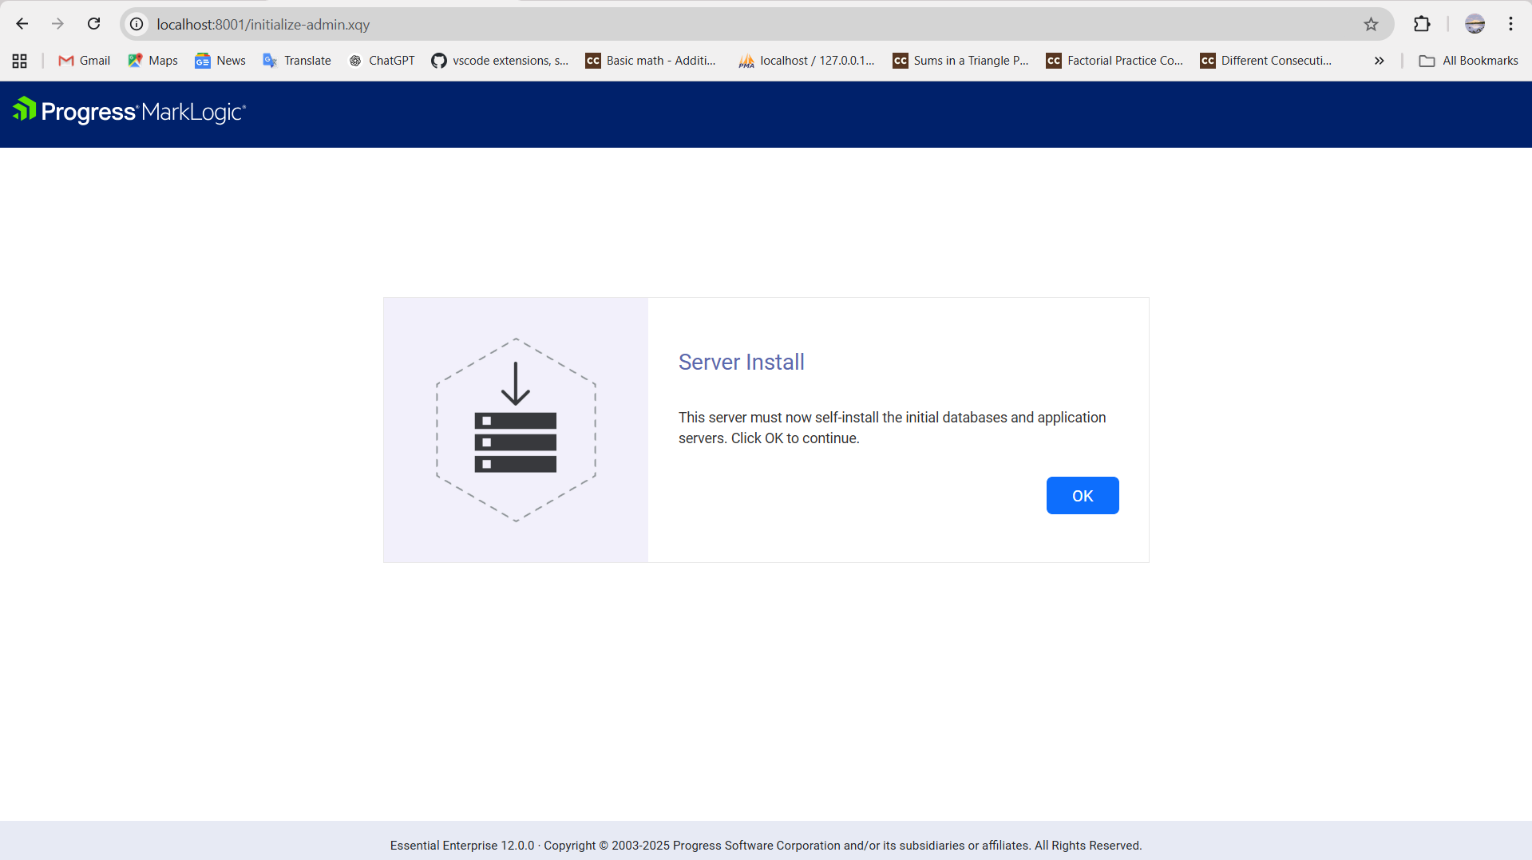

**3. Login to Admin Console**

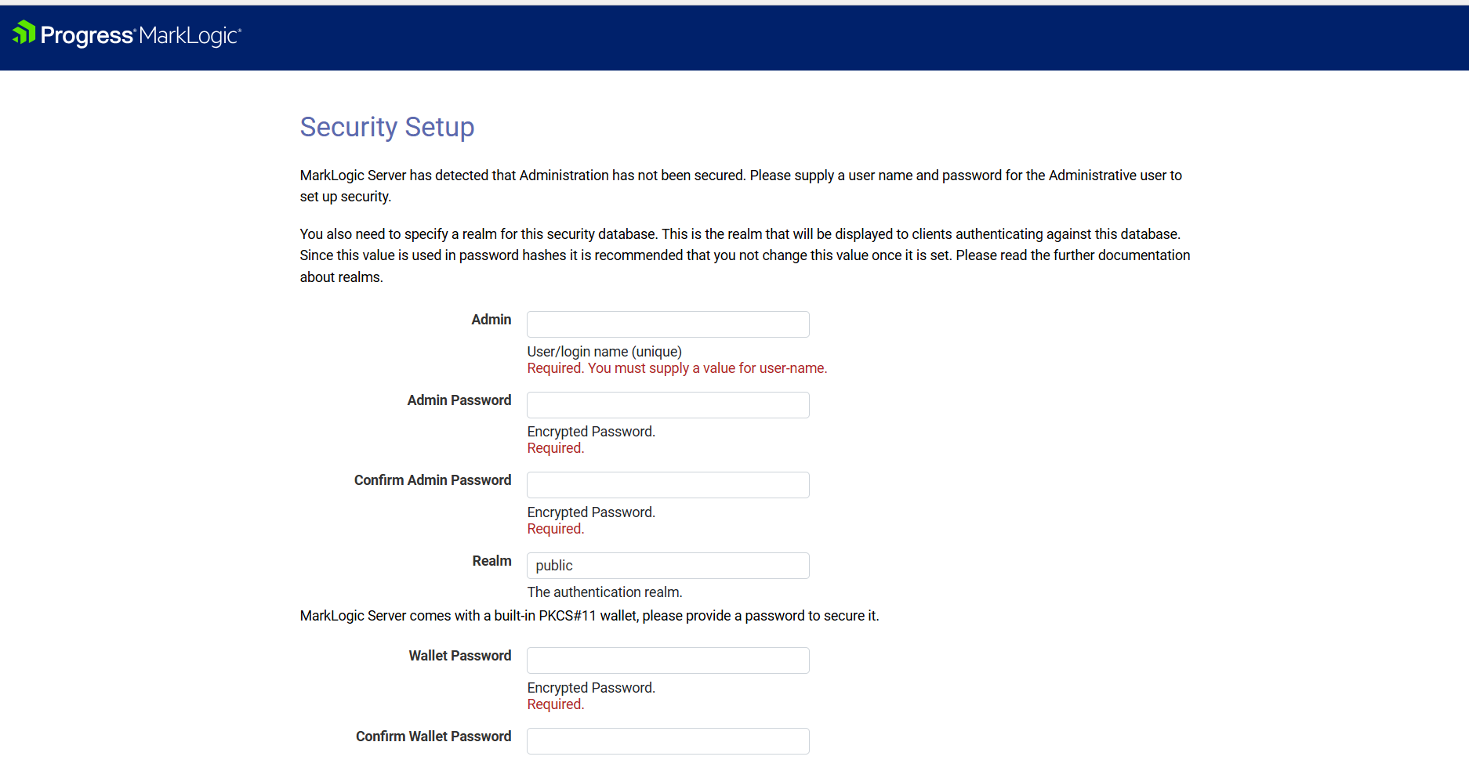

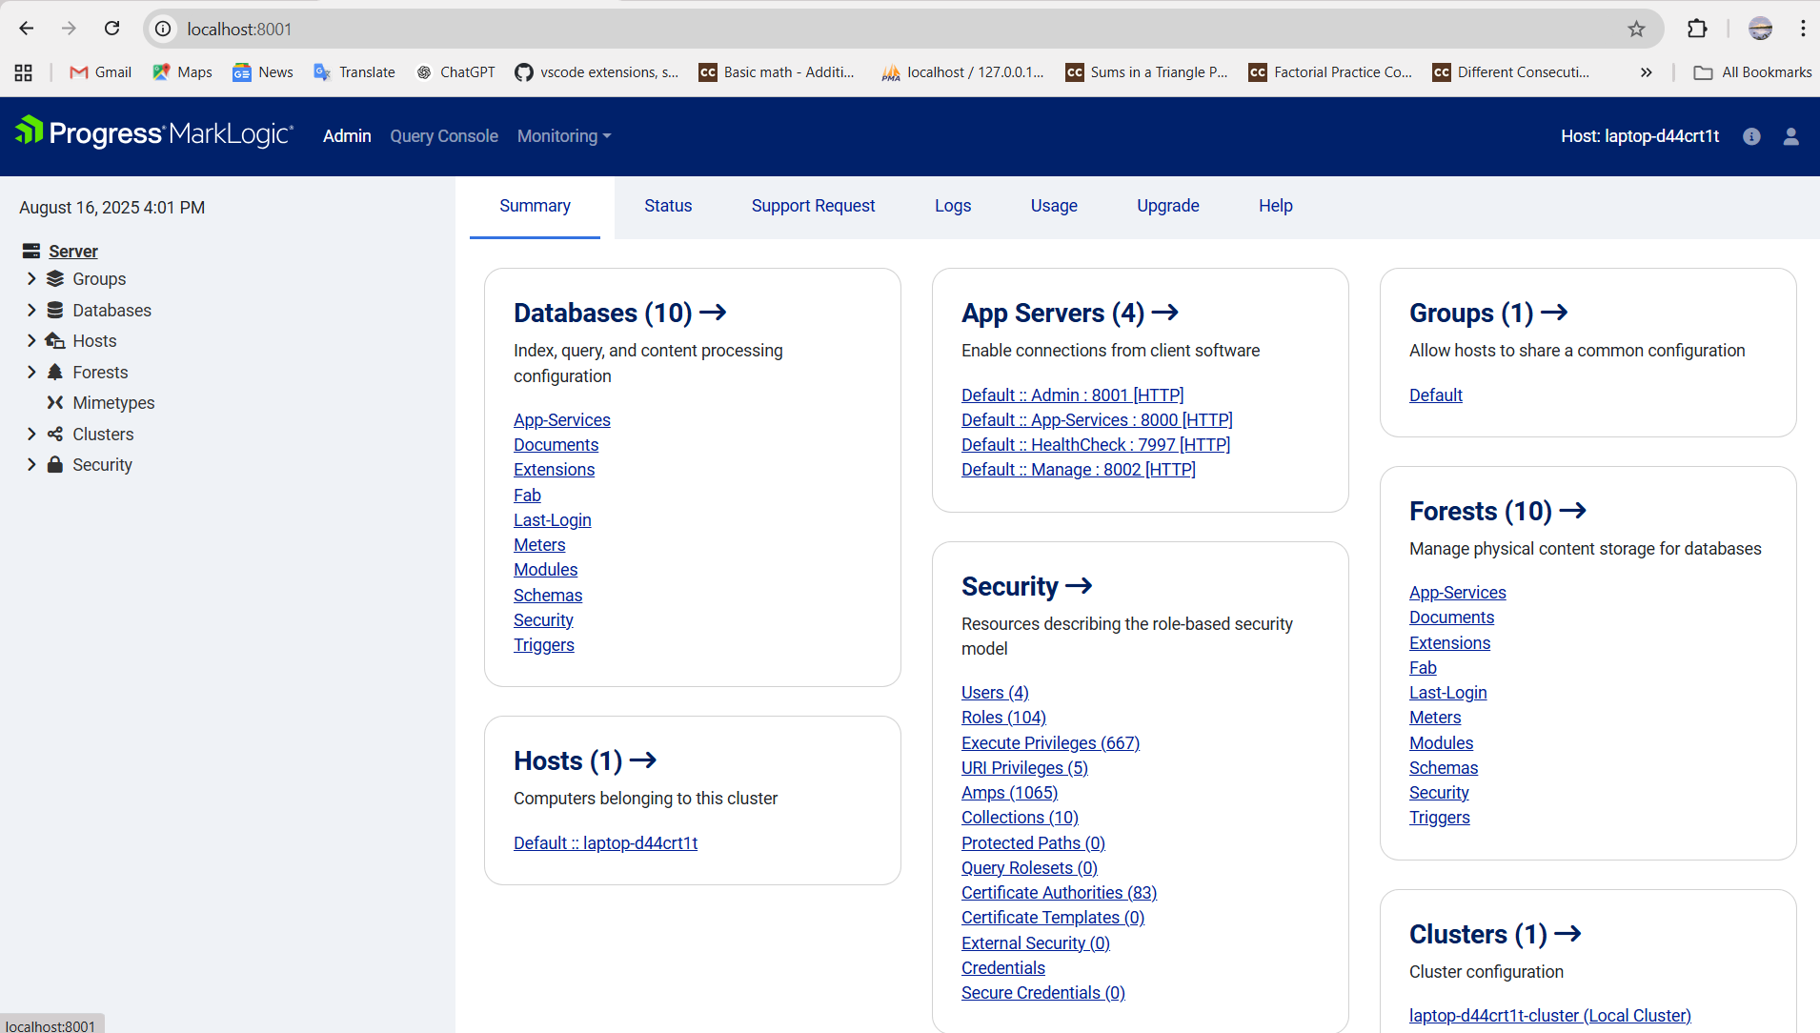

**4. Create Database and Forest**

1. Create a new Database (e.g., `HealthcareDB`).  
2. Create a Forest (storage unit) and attach it to the database.  
3. MarkLogic will auto-index all inserted documents.

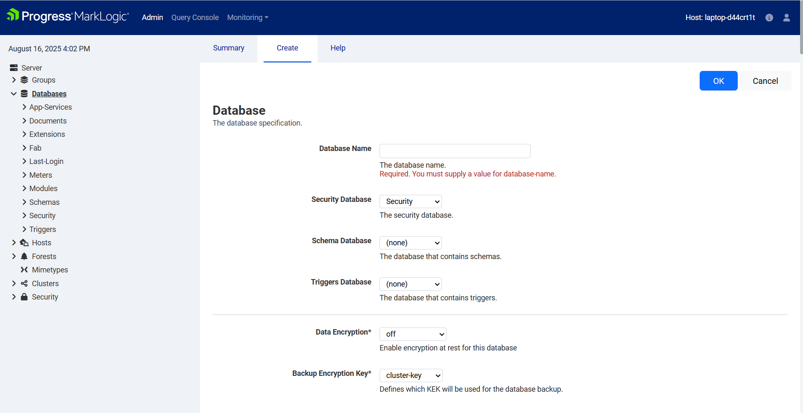

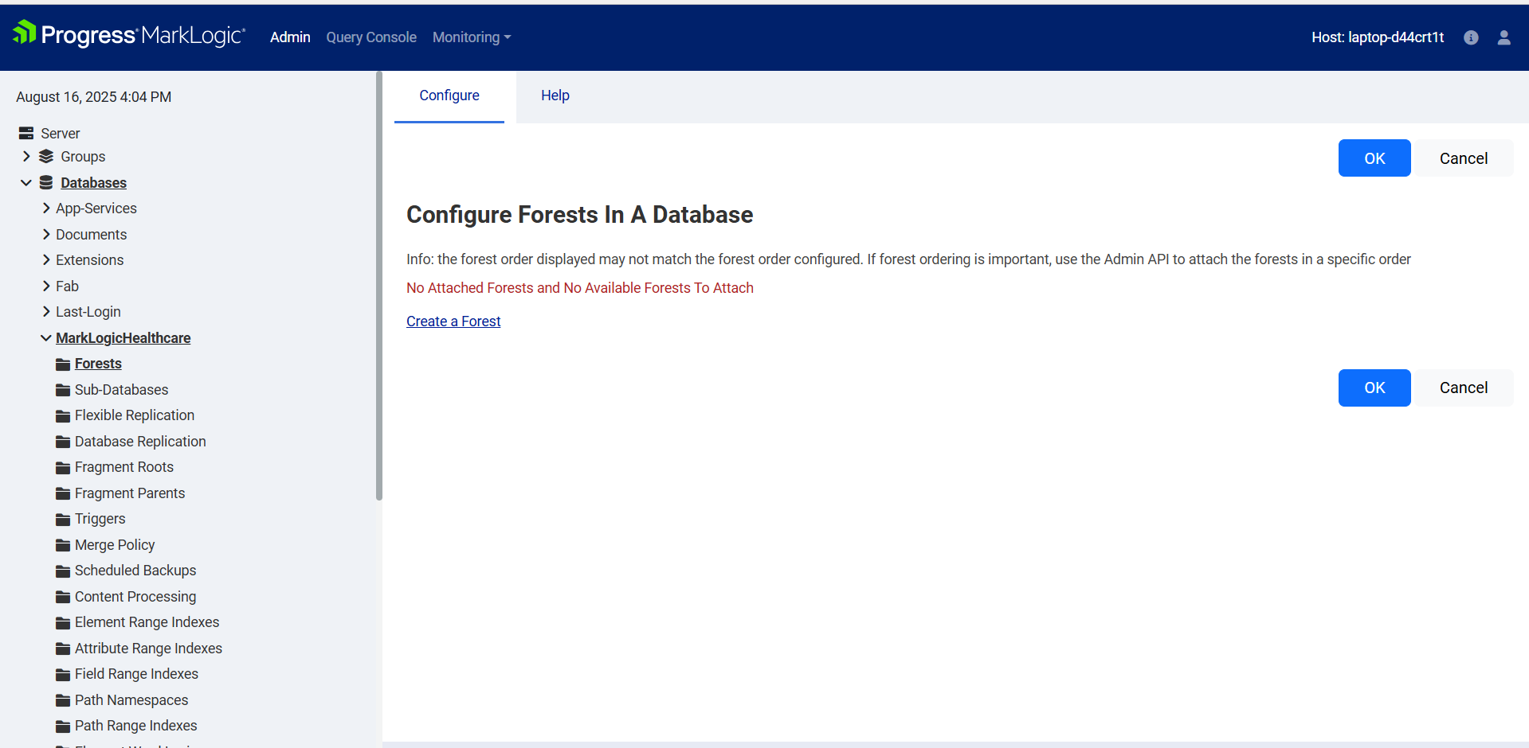

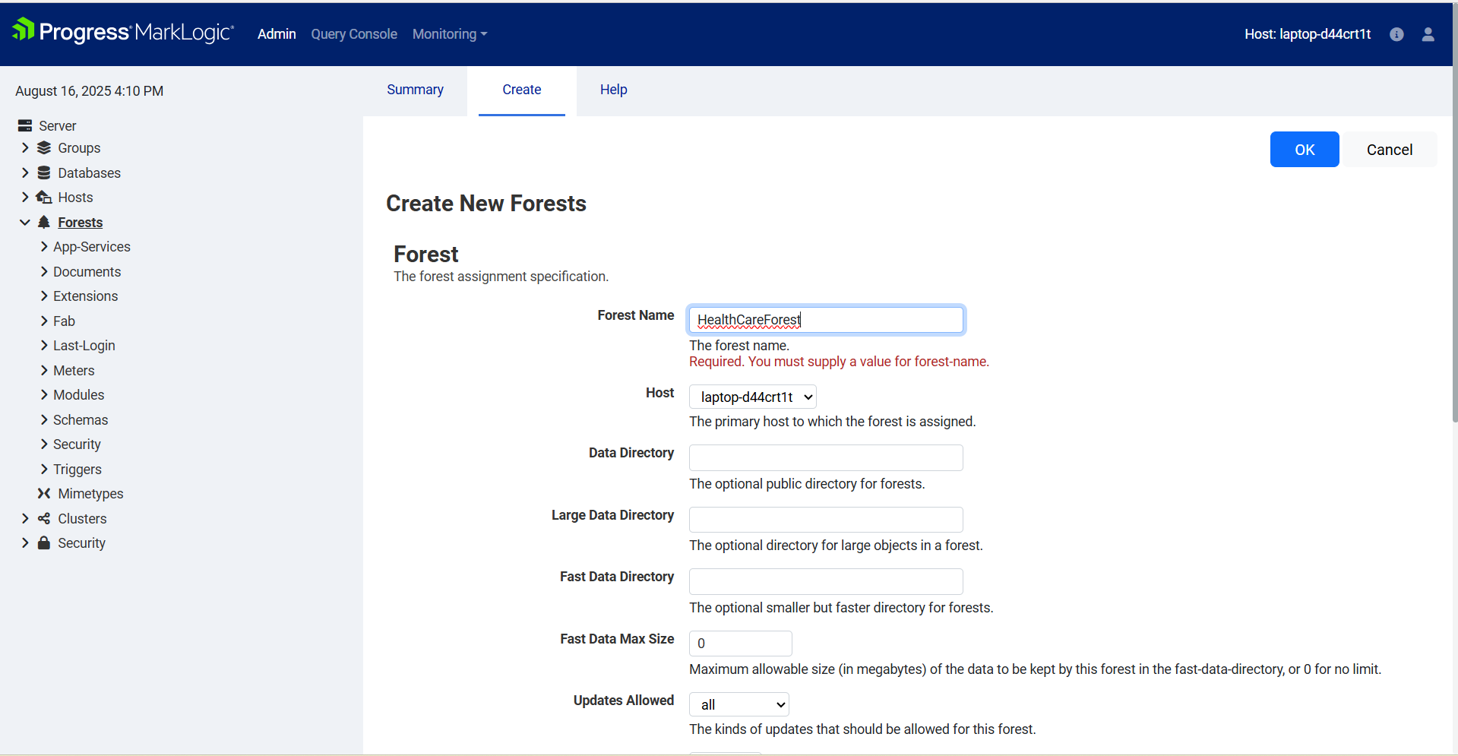

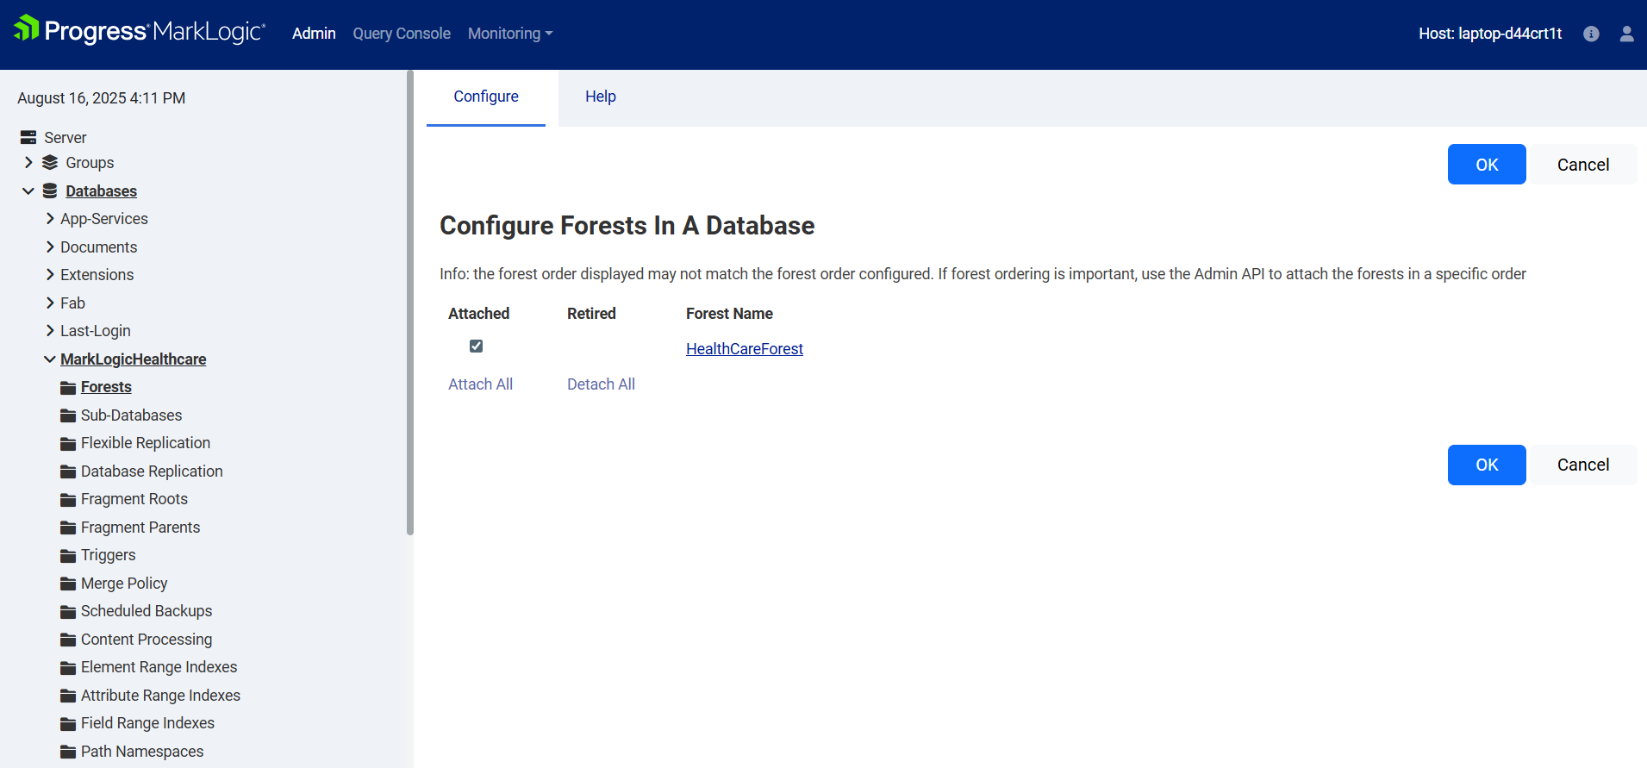

**5. Query execution: login to qconsole (localhost:8000)**

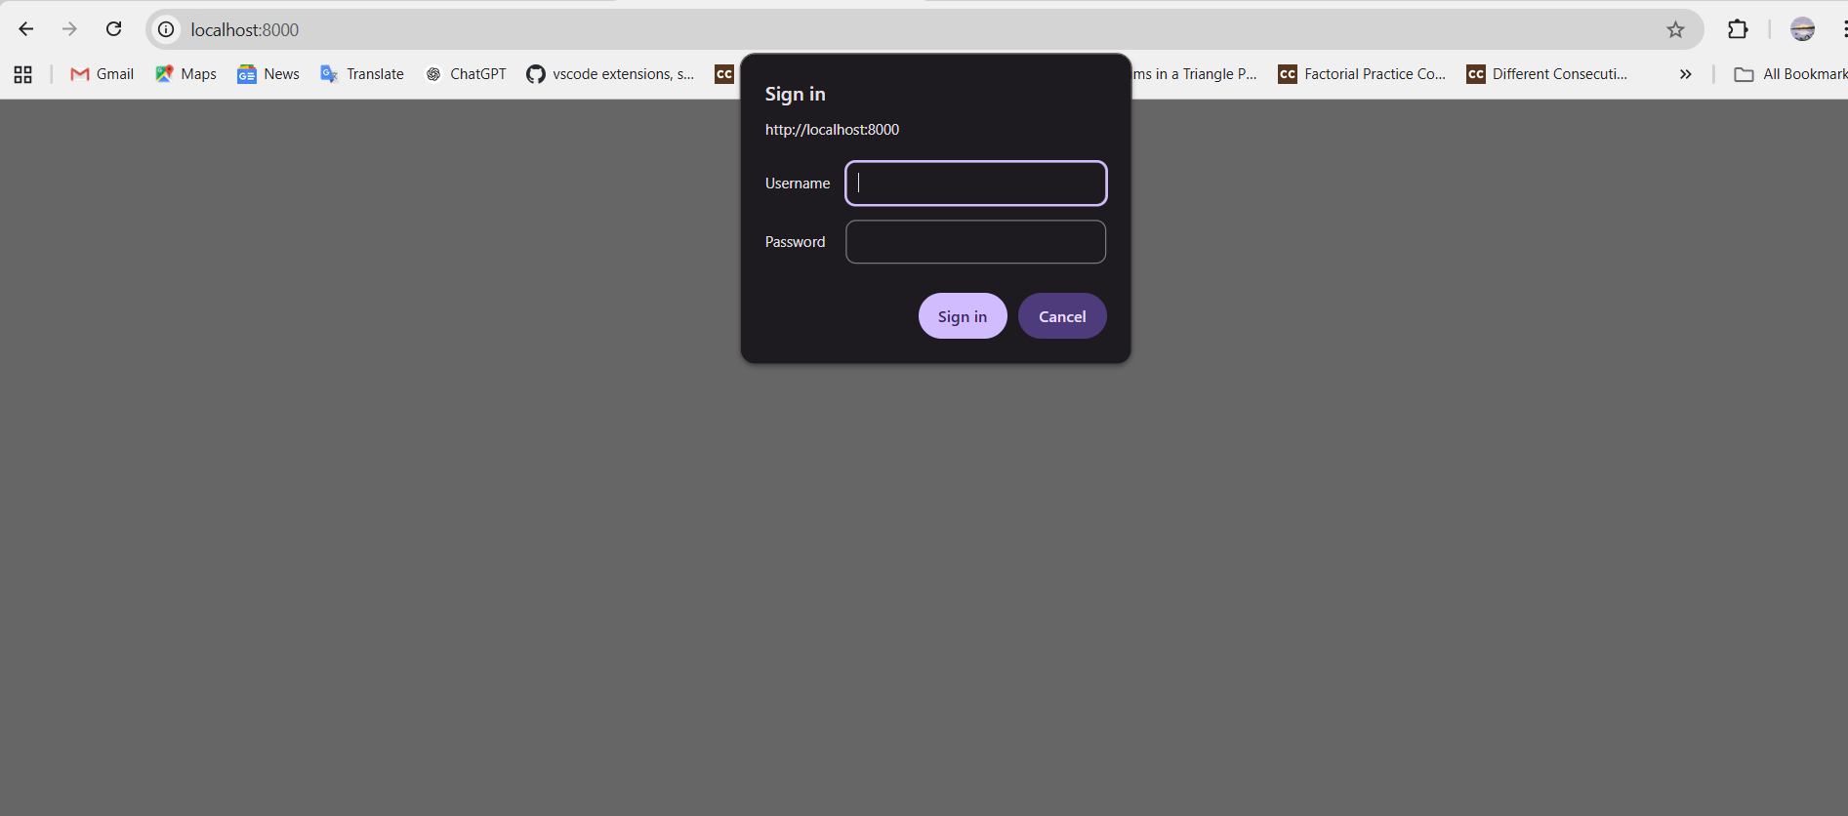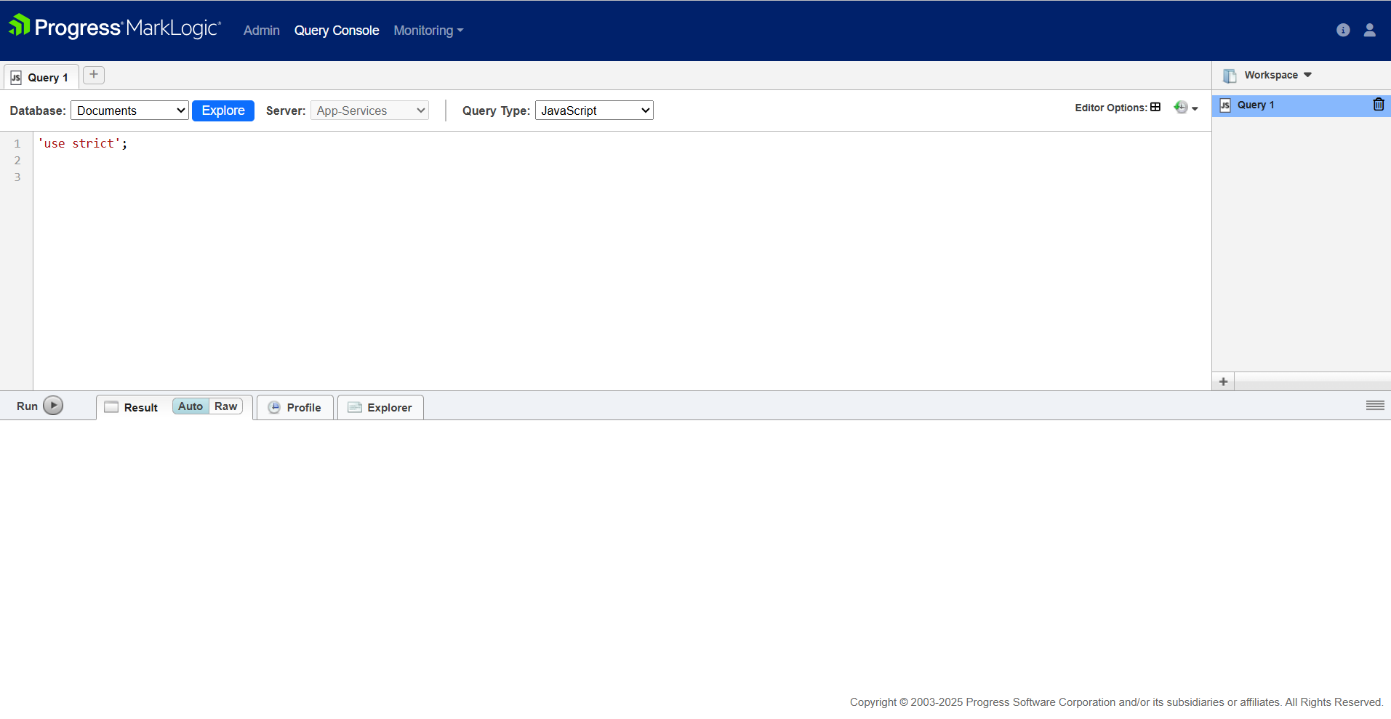

1. **Enter a record of patients (single entry at a time)**

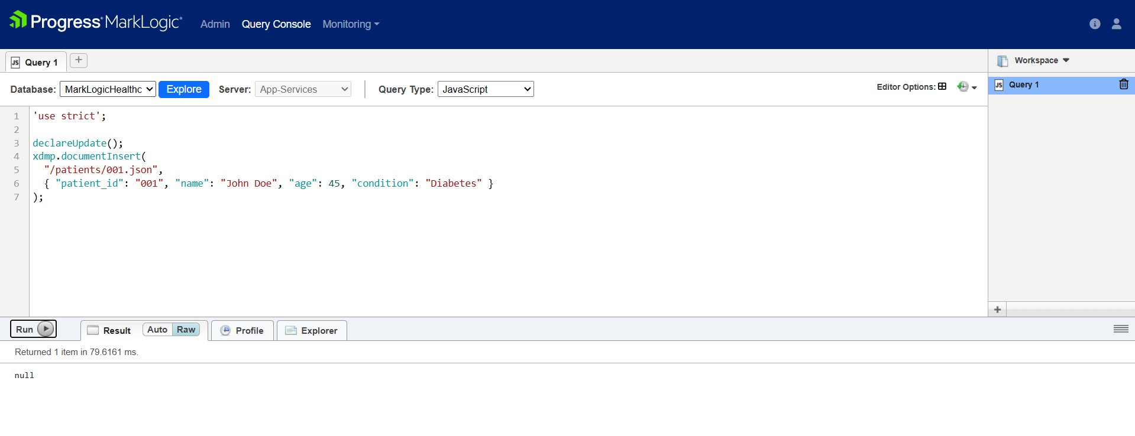

1. **Display single record**

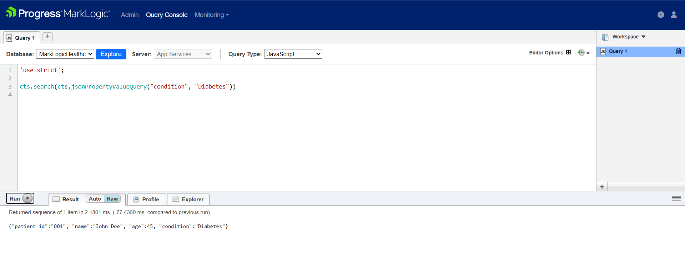

1. **Enter a record of patients (single entry at a time)**

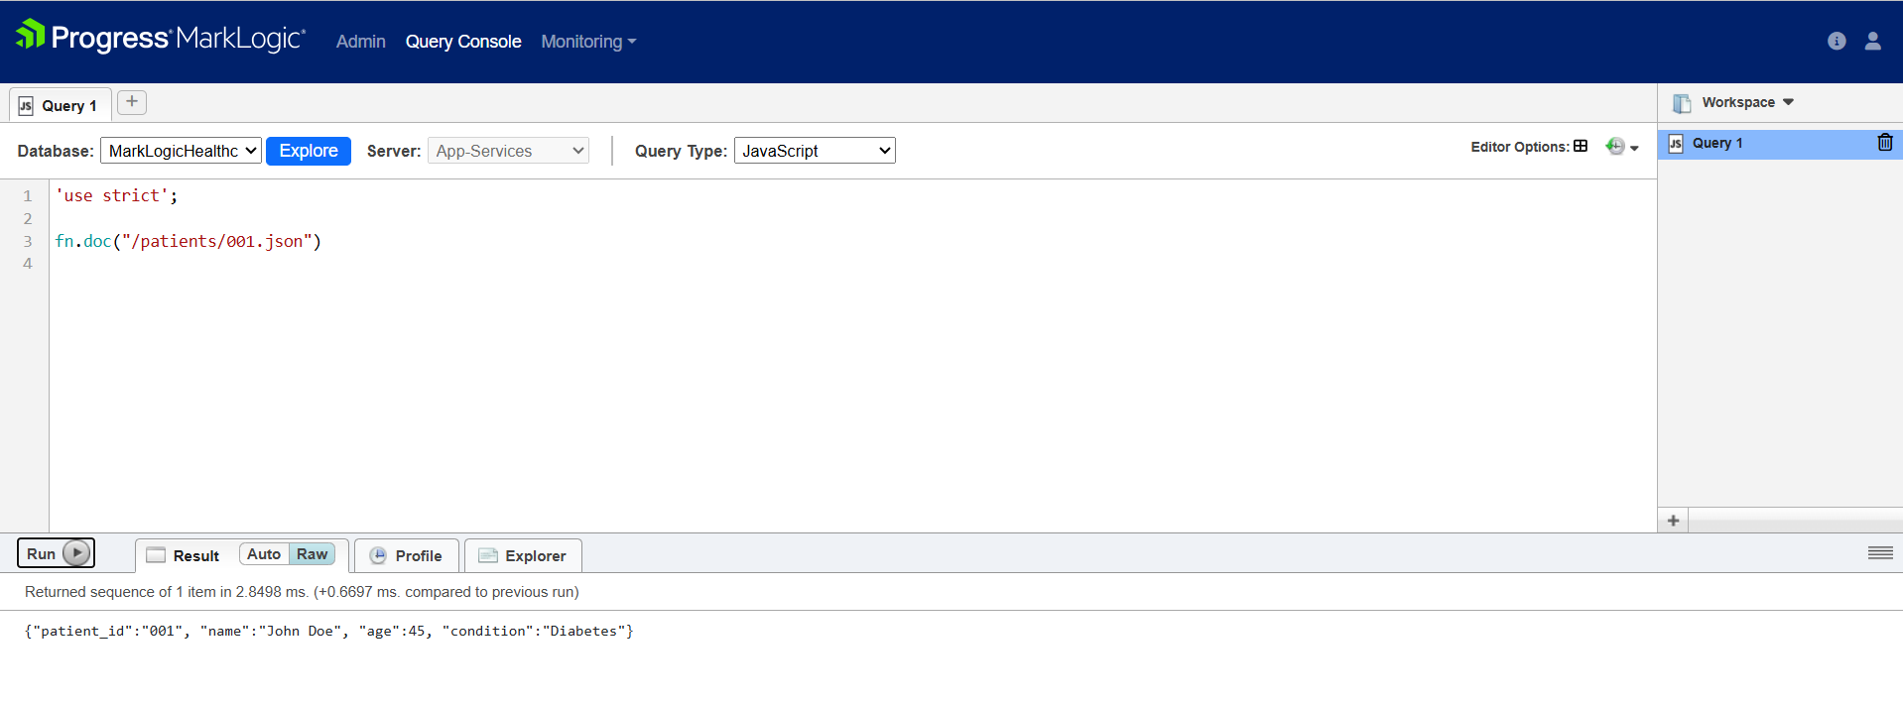

1. **Enter a record of patients (multiple entries at a time)**

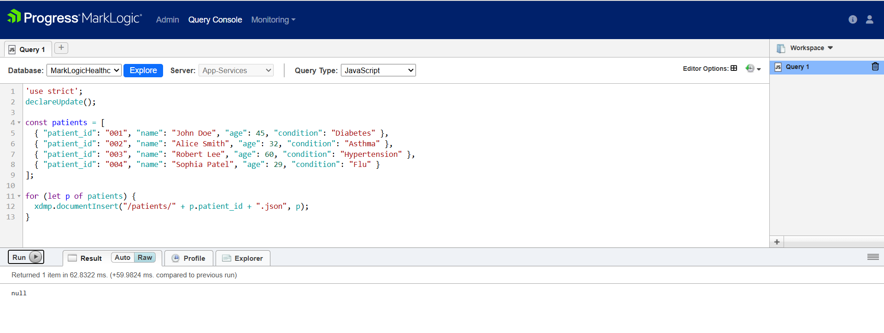

1. **Display all Entries**

